**CHAPTER FIVE**

**CONSUMER BEHAVIOUR MARKET RESEARCH AND ADVERTISEMENT**

**Learning Objectives**

By the end of this chapter the learner shall be able to;

i. The consumer decision making process

ii. Personalization, loyalty, satisfaction and trust in EC

iii. Methods of conduction market research online

**5.1 The consumer decision making process**

When consumers making purchasing decisions, people play different roles in the decision-making process. The major roles are as follows;

 Initiator. The person who first suggests or thinks of the idea of buying a particular product or service.

 Influencer. A person whose advice or view carries some weight in making a final purchasing decision.

 Decider. The person who ultimately makes a buying decision or any part of it whether to buy what to buy how to buy, or where to buy

 Buyer. The person who makes an actual purchase.

 User. The person who consumes or uses a product or service.

lf one individual plays all of these roles, the marketer needs to understand and target that individual. When more than one individual plays these different roles, it becomes more difficult to properly target advertising and marketing efforts.

**A generic Purchasing-decision model**

A general purchasing—decision model consists of five major phases (Kotler 2005). ln each phase, we can distinguish several activities and, in some, one or more decisions. The five phases are (1) need identification, (2) information search, (3) evaluation of alternatives, (4) purchase and deliver , and (5) post purchase behavior Although these

phases offer a general idea to the consumer decision-making process, one should not assume that every consumer’s decision-rnaking process will necessarily follow this order. In fact, some consumers may proceed to a point and then revert back to a previous phase, or they may skip a phase altogether.

**A Customer Decision Model In Web Purchasing**

The preceding generic purchasing—decision model was widely used in research on consumer-based EC. Below is a framework built by O’Keefe and lVlcEachern (1998) for a Web purchasing model. As shown in Exhibit 4.2, each of the phases of the purchasing model can be supported by both Consumer Decision Support System (CDSS) facilities and Internet and Web facilities. The CDSS facilities support the specific decisions in the process.

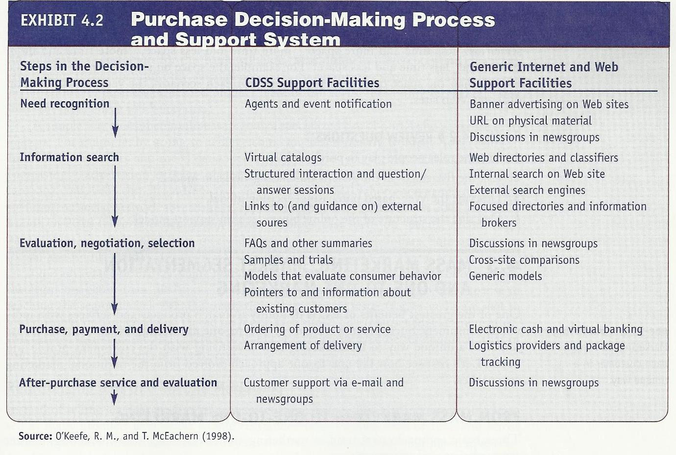

**5.2 Personalization, Loyalty, Satisfaction and Trust in EC**

Internet marketing facilitates the use of market segmentation and one-to-one marketing. The issues related to personalization are; personalization, collaborative filtering, customer loyalty permission marketing and trust.

**Personalization in E-Commerce**

Personalization refers to the matching of services, products, and advertising content to individuals and their preferences. The matching process is based on what a company knows about the individual user. This knowledge is usually referred to as a user profile. The user profile defines customer preferences, behaviors, and demographics. Profiles can be generated in several ways. The major strategies used to compile user profiles include the following:

 Solicit information directly from the user. This is usually done by asking the user to fill in a questionnaire or by conducting an interview with the user.

 Observe what people are doing online. A common way to observe what people are doing online is through use of a cookie—a data file that is stored on the user’s hard drive, frequently without disclosure or the user’s consent. Sent by a remote Web server over the Internet, the information stored will surface when the user’s browser again accesses the specific Web server, and the cookie will collect information about the user’s activities at the site. This is a common strategy but controversial in E-commerce.

 Build from previous purchase patterns. For example Amazon.com builds customer profiles to recommend books, CDs, and other products, based on what customers have purchased before, rather than asking customers, using cookies, or doing market research.

 Perform marketing research. Firms can research the market using tools that will be described in the next chapter.

 Make inferences. Infer from information provided by customers on other issues or by analyzing similar customers.

The Internet offers online retailers different ways to tailor services to their customers, including:

 Personalized services. Services built on a one—to—one communication channel requiring personal data from customers.

 Individual services. Recommendation services built on the sequence of clicks, page requests, or items that have been added to the shopping cart. This approach improves the shopping experience while also maintaining consumer anonymity.

 Universal services. Consumers use the product search function or read customer reviews. This approach does not require personal or context data.

**Customer Loyalty**

Customer loyalty refers to ―a deep commitment to rebuy or repatronize a preferred product/ service consistently in the future, thereby causing repetitive same-brand or same brand-set purchasing, despite situational influences and marketing efforts having the potential to cause switching behavior‖. Attracting and retaining loyal customers remains the most important issue for any selling company including e-tailers. Increased customer loyalty can bring cost savings to a company in various ways: lower marketing and advertising costs, lower transaction costs, lower customer turnover expenses, lower failure costs such as warranty claims, and so on. Customer loyalty also strengthens a company’s market position because loyal customers are kept away from the competition.

**E-Loyalty**

E-loyalty refers to a customer’s loyalty to an e-tailer or a manufacturer that sells directly online or to loyalty programs delivered online or supported electronically Customer acquisition and retention is a critical success factor in e-tailing. The expense of acquiring a new customer can be over $100; even for Amazon.com, which has a huge reach, it is more than $15. In contrast, the cost of maintaining an existing customer at Amazon.com is $2 to $4. Companies can foster e-loyalty by learning about their customers needs, interacting with customers, and providing superb customer service.

**Satisfaction In EC**

Given the changing dynamics of the global marketplace and the increasingly intense competition, delivering world-class customer online experience becomes a differentiating strategy. Satisfaction is one of the most important consumer reactions in the B2C online environment. Maintaining customer satisfaction in the online shopping experience is as important as the high level of satisfaction associated with several key outcomes (e.g., repeat purchase, positive word-of-mouth, and so on). Eighty percent of highly satisfied online consumers would shop again within 2 months, and 90 percent would recommend Internet retailers to others. However, 87 percent of dissatisfied consumers would permanently leave their Internet retailers without any complaints.

If certain Web site features, such as reliability of content, loading speed, and usefulness, fail to perform properly, customer satisfaction will drop dramatically In contrast, if features such as those that make the usage enjoyable, entertaining, and fun perform well, they will surprise customers and result in a radical jump in customer satisfaction.

**Trust In EC**

Trust is the psychological status of depending on another person or organization to achieve a planned goal. When people trust each other, they have confidence that as transaction partners they will keep their promises. However, both parties in a transaction assume some risk. In the electronic marketplace, sellers and buyers do not meet face to face. Trust is particularly important in global EC transactions due to the difficulty of taking legal action in cases of a dispute or fraud and the potential for conflicts caused by differences in culture and business environments. ln addition to sellers and buyers trusting each other, both must have trust in the EC computing environment and in the EC infrastructure. If people do not trust the security of the EC infrastructure, they will not feel comfortable about using credit cards to make EC purchases.

Increasing Trust in EC Consumer trust is fundamental to successful online retailing. Urban et al. (2000) advocated that trust is the currency of the Internet. Trust can be increased by;

 Affiliating with an Objective Third Party. This approach aims at building consumer trust by affiliating with trusted third parties. Internet stores can put hypertext links on their Web sites to other trusted targets, including reputable companies or well-known portals.

 Establish Trustworthiness. Trustworthiness can be achieved through three key elements: integrity competence, and security. Integrity conveys an overall sense of the ability of the Internet store to build an image of strong justice and fulfill all of the promises that have been made to the customers (i.e., offering money— back guarantee with the products and clearly stating the guarantee policy on the Web.

**5.3 Market Research For EC**

The objective of market research is to discover information and knowledge that explain the associations among consumers, products, marketing methods, and marketers. Its aim is to discover marketing opportunities and issues, to create marketing plans, to better understand the purchasing process, and to evaluate marketing performance. On the Web, the objective is to turn browsers into buyers. Market research includes gathering information about topics such as the economy industry firms, products, pricing, distribution, competition, promotion, and consumer purchasing behavior.

**Methods for Conducting Market Research Online**

EC market research can be conducted through conventional methods, or it can be done with the assistance of the Internet. On the Web market researchers can conduct a very large study much more cheaply than with other methods. The larger the sample size, the larger the accuracy and the predictive capabilities of the results.

Below are the methods used to conduct market research on-line

1. Implementing Web-based surveys - these are becoming popular with companies and researchers

2. Online focus groups - Several research firms create panels of qualified Web regulars to participate in online focus groups

3. Hearing directly from customers - customers are asked directly what they think about a product or service.

4. Observing customers - To avoid some of the problems of online surveys, especially the giving of false information, some marketers choose to learn about customers by observing their behavior rather than by asking them questions below are some of the methods that can be used to collect customer information.

✓ **transaction log**. A record of user activities at a company’s Web site

✓ **clickstream behavior.** Customer movements on the Internet

✓ **Web bugs.** Tiny graphics files embedded on e-mail messages and in Web sites that transmit information about the users and their movements to a Web server

✓ **Spyware.** Software that gathers user information over an Internet

connection without the user’s knowledge

✓ **clickstream data**. Data that occur inside the Web environment; they provide a trail of the user’s activities (the user’s clickstream behavior) in the Web site

✓ **Collaborative filtering.** A market research and personalization method that uses customer data to predict, based on formulas derived from behavioral sciences, what other products or services a customer may enjoy; predictions can be extended to other customers with similar profiles

**Limitations of Online Market Research**

– Too much data may be available

– To use data properly, it should be organized, edited, condensed, and summarized

– The solution to this problem is to automate the process by using data warehousing and data mining

– Some of the limitations of online research methods are:

• Accuracy of responses

• Loss of respondents because of equipment problems

• The ethics and legality of Web tracking

• Lack of representativeness in samples of online users

**Chapter Review Questions**

9. Relate cookies, Web bugs, and spy ware to market research.

10. Describe the limitations of online market research.

11. Describe the issue of trust in EC and how to increase it.

12. Explain how personalization is done in E-Commerce?